**Experiment-1**

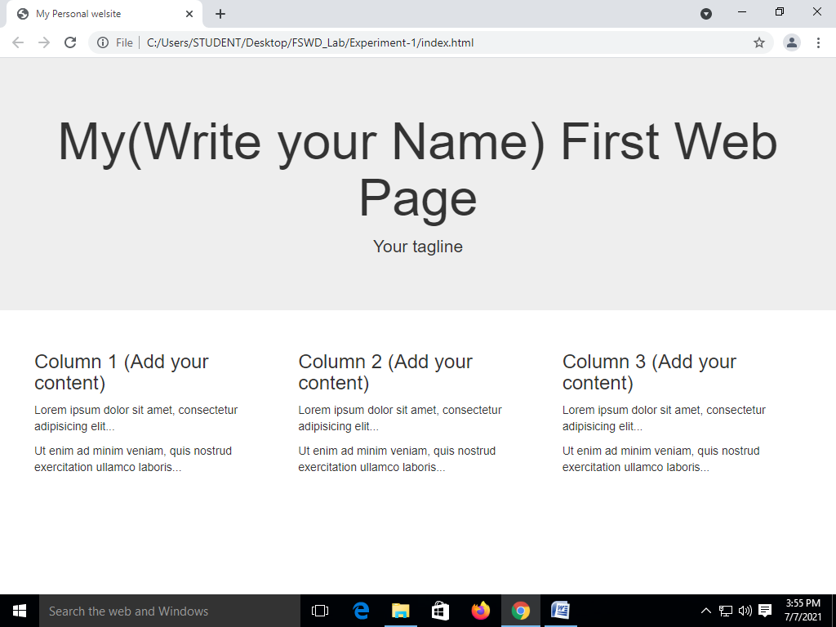

**Experiment-2**

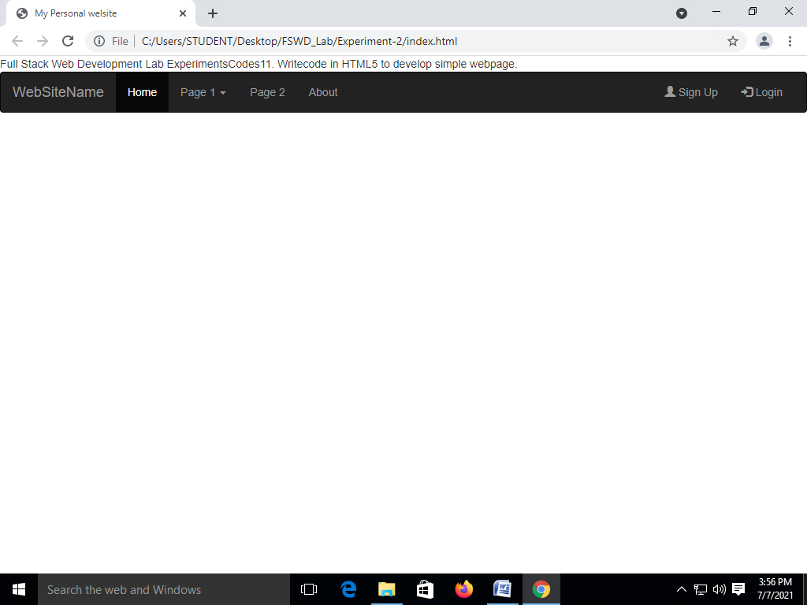

**Experiment-3:**



**Experiment**:4

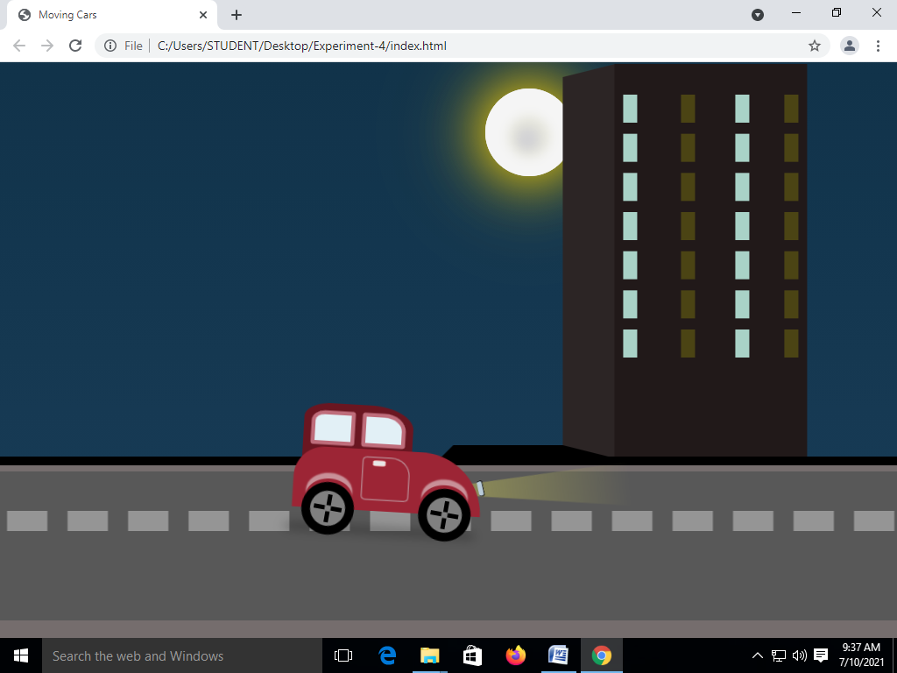

**Experiment:5**

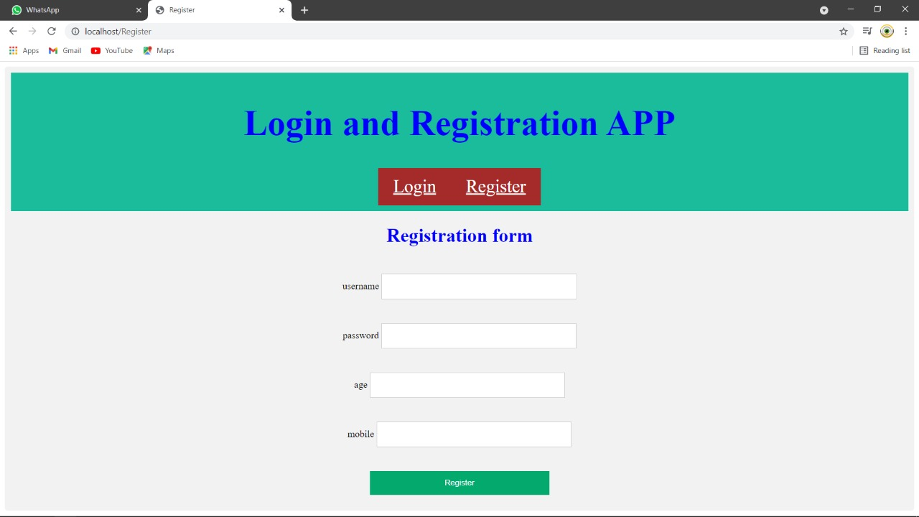

In this experiment all of u write Registration form .Compulsory fill the details.

**Experiment:6**

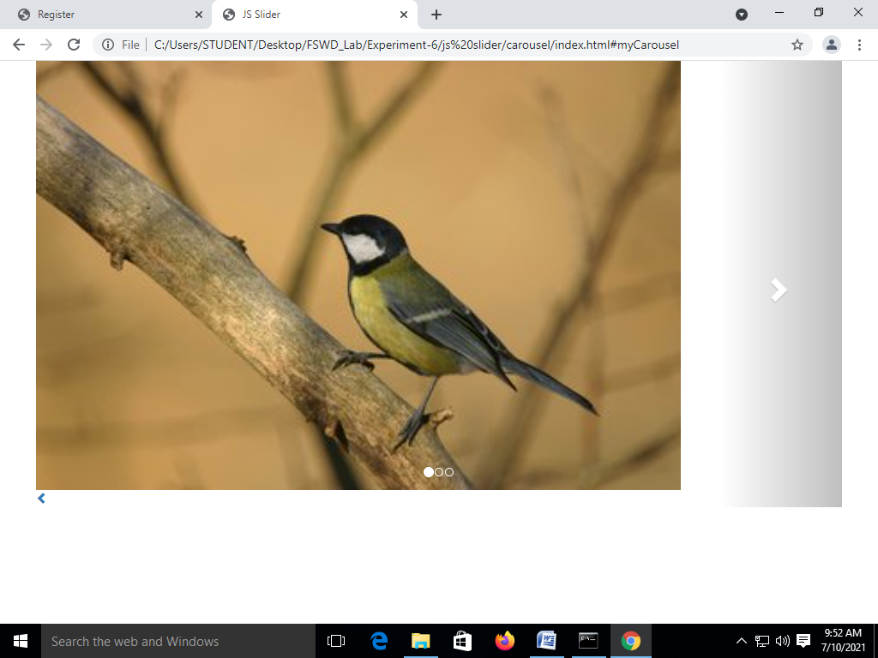

**Experiment 7:Git version control**

C:\Users\STUDENT\Desktop\cse-b>git --version

git version 2.32.0.windows.1

C:\Users\STUDENT\Desktop\cse-b>git config --global user.name "maha"

C:\Users\STUDENT\Desktop\cse-b>git config --global user.email "mahalakshmi.valluri@cmritonline.ac.in"

C:\Users\STUDENT\Desktop\cse-b>git config --list

diff.astextplain.textconv=astextplain

filter.lfs.clean=git-lfs clean -- %f

filter.lfs.smudge=git-lfs smudge -- %f

filter.lfs.process=git-lfs filter-process

filter.lfs.required=true

http.sslbackend=openssl

http.sslcainfo=C:/Program Files/Git/mingw64/ssl/certs/ca-bundle.crt

core.autocrlf=true

core.fscache=true

core.symlinks=false

pull.rebase=false

credential.helper=manager-core

credential.https://dev.azure.com.usehttppath=true

init.defaultbranch=master

user.name=maha

[user.email=mahalakshmi.valluri@cmritonline.ac.in](mailto:user.email=mahalakshmi.valluri@cmritonline.ac.in)

C:\Users\STUDENT\Desktop\cse-b>git init

Initialized empty Git repository in C:/Users/STUDENT/Desktop/cse-b/.git/

C:\Users\STUDENT\Desktop\cse-b>git add .

C:\Users\STUDENT\Desktop\cse-b>git status

On branch master

No commits yet

Changes to be committed:

(use "git rm --cached <file>..." to unstage)

new file: index.html

C:\Users\STUDENT\Desktop\cse-b>git commit -m "second commit"

[master (root-commit) c7bf214] second commit

1 file changed, 12 insertions(+)

create mode 100644 index.html

C:\Users\STUDENT\Desktop\cse-b>git log --oneline

c7bf214 (HEAD -> master) second commit

C:\Users\STUDENT\Desktop\cse-b>git remote add origin <https://github.com/Annavarapu-Mahalakshmi/cse-b.git>

C:\Users\STUDENT\Desktop\cse-b>git push -u origin master

Username for 'https://github.com': mahalakshmi.valluri@cmritonline.ac.in

Password for 'https://mahalakshmi.valluri@cmritonline.ac.in@github.com':

Enumerating objects: 3, done.

Counting objects: 100% (3/3), done.

Delta compression using up to 4 threads

Compressing objects: 100% (2/2), done.

Writing objects: 100% (3/3), 395 bytes | 395.00 KiB/s, done.

Total 3 (delta 0), reused 0 (delta 0), pack-reused 0

remote:

remote: Create a pull request for 'master' on GitHub by visiting:

remote: https://github.com/Annavarapu-Mahalakshmi/cse-b/pull/new/master

remote:

To https://github.com/Annavarapu-Mahalakshmi/cse-b.git

* [new branch] master -> master

Branch 'master' set up to track remote branch 'master' from 'origin'.

C:\Users\STUDENT\Desktop\cse-b>git clone https://github.com/Annavarapu-Mahalakshmi/cse-b.git

Cloning into 'cse-b'...

remote: Enumerating objects: 6, done.

remote: Counting objects: 100% (6/6), done.

remote: Compressing objects: 100% (3/3), done.

remote: Total 6 (delta 0), reused 3 (delta 0), pack-reused 0

Receiving objects: 100% (6/6), done.

**Experiment:8**

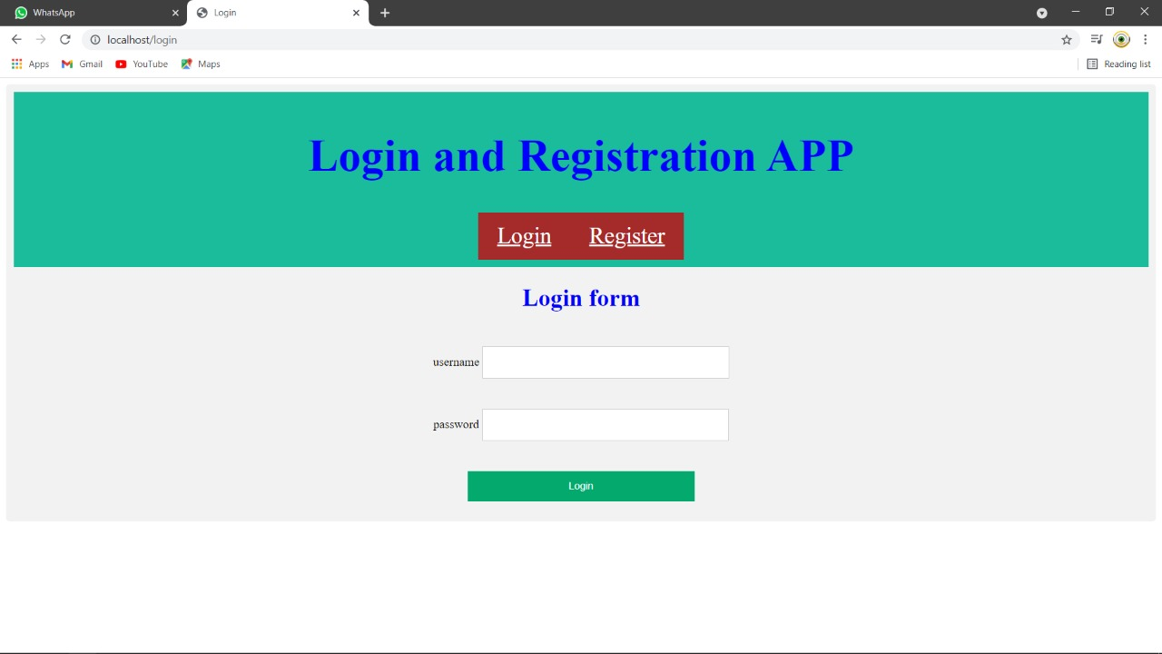

**Welcome**

**Experiment:9**



**Experiment 10:**

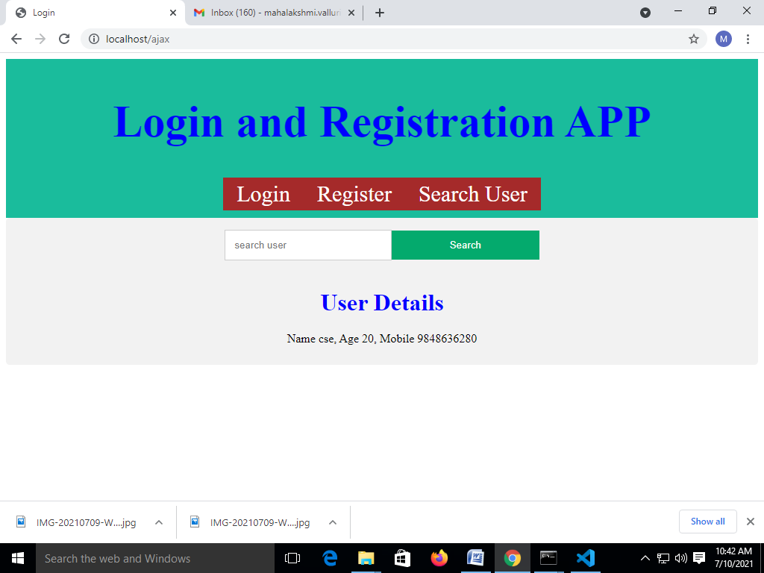

**Experiment:11**

